

Draw It or Lose It

CS 230 Project Software Design Template
Version 1.0

Table of Contents

CS 230 Project Software Design Template 1
Table of Contents 2
Document Revision History 2
Executive Summary 3
Requirements 3
Design Constraints 3
System Architecture View 3
Domain Model 3
Evaluation 4
Recommendations 5

Document Revision History

Version | Date | Author | Comments
1.0 | 05/22/2026 | David Wakefield | Initial software design document created for the Draw It or Lose It game application, including the executive summary, requirements, design constraints, domain model, platform evaluation, and recommendations.

Executive Summary

The Gaming Room needs to expand its game, Draw It or Lose It, into a web-based application that can work across different platforms. The main problem is making sure the application is built in a way that keeps the game data organized, prevents duplicate names, and supports multiple users without creating confusion in the system.

The solution is to design the application using object-oriented programming. The game will use separate classes for games, teams, and players, while also using a shared base class called Entity for common information like ID and name. This helps keep the code cleaner and avoids repeating the same information in different places.

The application will also use the singleton pattern in the GameService class so only one instance of the service is managing the game data at a time. This is important because the service is responsible for creating unique IDs and keeping track of the games, teams, and players. The iterator pattern will also be used to search through existing names before adding a new game, team, or player. This helps make sure names are not duplicated.

The client should understand that this design gives the application a strong foundation. It supports the current requirements and also makes it easier to add more features later, such as more players, more games, user accounts, or database support. This approach keeps the application organized, easier to maintain, and better prepared for a web-based distributed environment.

Requirements

The Gaming Room wants to take its current game, Draw It or Lose It, and make it available as a web-based application that can work across different platforms. The main business requirement is to allow more users to access the game from different devices instead of being limited to one environment.

The application needs to support multiple games, teams, and players. Each game, team, and player must have a unique ID so the system can track them correctly. The client also wants game and team names to be unique so users can check if a name is already being used before choosing one.

From a technical side, the application needs to be organized using object-oriented programming. The design uses an Entity base class to hold common information like ID and name. The Game, Team, and Player classes build from that base class. The GameService class manages the game data and uses the singleton pattern so only one instance controls the data at a time.

The system also needs to be designed for a web-based distributed environment. This means the application should be able to support users connecting from different platforms, while keeping the data consistent, secure, and easy to manage.

Design Constraints

Since Draw It or Lose It is being designed as a web-based distributed application, there are several constraints that need to be considered. The application has to work for users who may be connecting from different devices, operating systems, and locations. This means the design cannot be built for only one type of computer or platform. It needs to be flexible enough to support different clients through a web browser or future mobile access.

One major constraint is keeping the game data consistent. Since the application may eventually have multiple users accessing it at the same time, the system needs to make sure games, teams, and players are tracked correctly. Each game, team, and player needs a unique ID, and names should be checked before new objects are created so duplicates are not added.

Another constraint is managing the application service correctly. The GameService class should only have one active instance using the singleton pattern. This matters because GameService controls the game data and assigns unique IDs. If more than one GameService object existed at the same time, the application could create duplicate IDs or lose track of which games, teams, and players already exist.

Security is also a constraint in a distributed environment. Since users may connect over a network, the application must be designed to protect user information and prevent unauthorized access. As the application grows, this could include secure login, encrypted communication, and controlled access to game data.

Performance and scalability are also important. The application may start small, but it should be designed so more users, games, teams, and players can be added later without having to rebuild the entire system. Using separate classes and clear object-oriented design makes the code easier to maintain and expand.

These constraints affect development because the application must be built with organization, consistency, security, and future growth in mind. The design needs to support the current requirements while also preparing the application for a larger web-based environment.

System Architecture View

No additional system architecture view is required for this project. This section is included as a reminder that future projects may require a description of the system architecture, physical components, tiers, communication flow, and storage design.

Domain Model

The UML class diagram shows how the main parts of the Draw It or Lose It application are connected. The diagram includes the GameService, Game, ProgramDriver, and SingletonTester classes. GameService is the main service class that manages the list of games. It stores the games in a List<Game>, keeps track of the next game ID, and has methods for adding and finding games.

The Game class represents an individual game in the application. Each Game object has an ID and a name. The GameService class has a relationship with the Game class because GameService stores and manages multiple Game objects. This is shown in the diagram with GameService connected to Game, meaning one GameService can manage many games.

The ProgramDriver class contains the main method. Its job is to run and test the application. It uses GameService to create or retrieve games. The SingletonTester class is used to test that the singleton pattern is working correctly. This helps confirm that only one instance of GameService exists while the application is running.

The diagram demonstrates encapsulation because the class attributes, such as games, nextGameId, id, and name, are private. These values are accessed through public methods instead of being changed directly. This helps protect the data and keeps the application more organized.

The diagram also demonstrates the singleton design pattern through the GameService class. GameService has a static instance of itself and a static getInstance() method. This design makes sure only one GameService object is created. That is important because GameService manages the game list and assigns unique game IDs. If more than one GameService existed, the application could create duplicate IDs or lose track of game data.

The design also supports efficient software requirements by keeping responsibilities separated. GameService manages game data, Game represents the game object, ProgramDriver runs the application, and SingletonTester checks the singleton behavior. This makes the code easier to understand, test, and maintain.
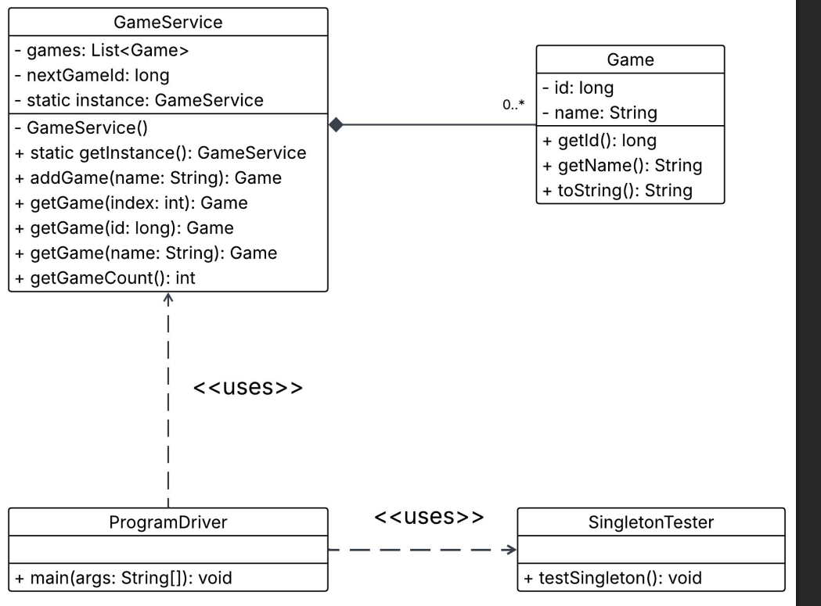

Evaluation

The operating platforms all have strengths and weaknesses that need to be considered for Draw It or Lose It. Since the client wants the game to work in a web-based distributed environment, the best solution should support multiple users, different devices, secure communication, and future growth. The table below compares Mac, Linux, Windows, and mobile devices based on server-side use, client-side support, and development tools.

Development Requirements | Mac | Linux | Windows | Mobile Devices
Server Side | Mac can be used for server-side development, but it is usually not the first choice for hosting a large web-based application. It is stable and reliable, but Apple hardware and hosting costs can be higher. Mac is better as a development machine than as the main production server. | Linux is a strong choice for server-side hosting because it is stable, secure, flexible, and commonly used for web servers. It also works well with cloud hosting and can handle a distributed application efficiently. The main weakness is that it may require more technical knowledge to manage. | Windows can be used for server-side hosting, especially with Microsoft tools and services. It has a familiar interface and good enterprise support. However, it may require more licensing costs and may not be as lightweight or flexible as Linux for web hosting. | Mobile devices are not a good choice for server-side hosting. They do not have the same reliability, storage, processing power, or network stability needed to host a distributed web application. Mobile devices are better suited as clients that connect to the server.
Client Side | Mac users can access the game through a web browser, which makes support easier. The main development concern is testing the game on browsers commonly used on Mac, such as Safari and Chrome. Supporting Mac adds some testing time but is manageable. | Linux users can also access the game through a browser. Since Linux users may use different browsers and distributions, testing may take extra time. However, web standards make Linux client support reasonable as long as the application is browser-based. | Windows is one of the most important client platforms because many users will access the game from Windows computers. The application should be tested on popular browsers such as Chrome, Edge, and Firefox. Supporting Windows is necessary because it will likely be a large part of the user base. | Mobile devices require extra attention because screen sizes, touch controls, and performance can vary. The game should use responsive design so it works on phones and tablets. Mobile support may increase development time, but it is important for reaching more users.
Development Tools | Mac supports common development tools such as Java, Eclipse, IntelliJ IDEA, Visual Studio Code, Git, and web browsers for testing. It is also useful for testing Safari compatibility. The downside is that Mac hardware can be expensive. | Linux supports Java, Eclipse, IntelliJ IDEA, Visual Studio Code, Git, Apache, Tomcat, and many cloud/server tools. It is one of the best environments for server-side development and deployment. It is powerful, but developers need to be comfortable using command-line tools. | Windows supports Java, Eclipse, IntelliJ IDEA, Visual Studio Code, Git, and browser testing tools. It is user-friendly and common in development environments. The downside is that server deployment may involve more configuration or licensing depending on the tools used. | Mobile development may require tools for responsive web testing and possibly Android Studio or Xcode if the application becomes a native mobile app later. For now, the main need is browser testing on mobile devices and using responsive design tools to make sure the game works on smaller screens.

Recommendations

Analyze the characteristics of and techniques specific to various systems architectures and make a recommendation to The Gaming Room. Specifically, address the following:

1. Operating Platform:

The recommended operating platform for Draw It or Lose It is Linux for the server side of the application. Linux is a strong choice because it is stable, secure, cost-effective, and commonly used for web-based applications. Since The Gaming Room wants the game to expand to other computing environments, Linux can support a web application that users can access from Windows, Mac, Linux, and mobile devices through a browser.

2. Operating Systems Architectures:

Linux uses a reliable and flexible operating system architecture that works well for distributed applications. It supports multi-user access, multitasking, network communication, and strong permission controls. This makes it a good fit for a game application that may have many users connecting at the same time. A Linux server can host the application logic, while users connect from different client devices using a web browser. This keeps the main processing and data management on the server instead of depending on each user’s device.

3. Storage Management:

For storage management, the application should use a database system such as MySQL or PostgreSQL. A database would allow the system to store user accounts, games, teams, players, scores, and other game information in an organized way. This is better than only keeping the data in memory because stored data will not be lost when the application closes or the server restarts. A database also makes it easier to search, update, and protect the game data.

4. Memory Management:

Linux manages memory efficiently by allocating memory to running processes and freeing memory when it is no longer needed. For Draw It or Lose It, this helps the server handle the game application while also supporting multiple users. The application should be designed so it does not store unnecessary data in memory for too long. The GameService class can manage active game data while long-term information should be saved in the database. This helps avoid memory waste and keeps the application running smoothly.

5. Distributed Systems and Networks:

Because The Gaming Room wants Draw It or Lose It to work across different platforms, the application should use a distributed system design. The main application can run on a Linux server, and users can connect to it from different devices through the internet. A web browser can act as the client, while the server handles the main game logic, data storage, and communication between users.

This design depends on reliable network communication. If a user loses connection, the application should be able to handle the interruption without losing important game data. The system should save important progress to the database and use proper error handling so users can reconnect when possible. Using a web-based design also makes updates easier because the main application can be updated on the server instead of requiring every user to install updates separately.

6. Security:

Security is very important because users may be accessing the game from different devices and networks. The application should protect user information by using secure login methods, encrypted communication, and proper access controls. Communication between the client and server should use HTTPS so data is encrypted while traveling across the network.

The Linux server should also use strong user permissions, firewall rules, regular security updates, and database access controls. Passwords should never be stored as plain text. They should be hashed and protected using accepted security practices. The application should also validate user input to help prevent attacks such as unauthorized access or database injection. These security steps help protect both the users and The Gaming Room’s application data.

